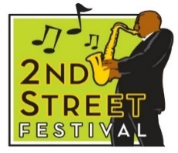

**2ND STREET FESTIVAL 2025**

**October 4 & 5**

**Historic Jackson Ward – Richmond, Virginia**

***ARTISTS’ ROW APPLICATION –----Please PRINT***

Artist Name: ____________________________________________________________________________________

Business Name: ________________________________________________________________________________________

Type of Original Artwork: ________________________________________________________________

Address: ________________________________________________________________________

City & State: __________________________________ Zip Code: ___________________

Email: __________________________________________ Mobile Number: _________________________________

Social Media Platforms: Are you on Instagram? _______, TikTok? ________, Facebook? _______,

Snap Chat? _______

List your Social Media handle on these platforms:

Why have you chosen an art career?

|  |
| --- |
|  |

Who are some of your biggest artistic influences?

|  |
| --- |
|  |

From 2022, list festivals/events you have previously vended. Must include city, state and year. Please use a separate sheet if necessary.

|  |
| --- |
|  |

If selected, what items and price range will you sell?

|  |
| --- |
|  |

Applicant agrees to:

* Display original art made by the applicant’s hand (no displaying or selling of other artists’ work). If you do sell others artwork, you will be removed from the festival.
* Remain with their vendor tent both days of the festival.
* **Include** 2 to 3 non-returnable pictures of your artwork sold at the festival.
* Complete and return this application by **May 19, 202****5**. Completion of this document does not guarantee being selected.

A committee will review and select the artists. Decisions made by June 12, 2025. All applicants will be notified. If selected, the artist must pay a non-refundable vendor fee of $300.00. The festival will provide a tented 10 x10 space, one 6’ table, two chairs & electricity.

___________________________________________________ __________________________________________

Signature Date

Application due/postmarked by **May 19, 2025**.

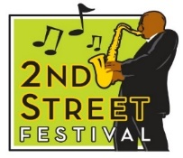

**Produced by Venture Richmond Events, 200 S. Third Street, Richmond, VA 23219**

**804.788.6466**