Riverfront Event Rental Application

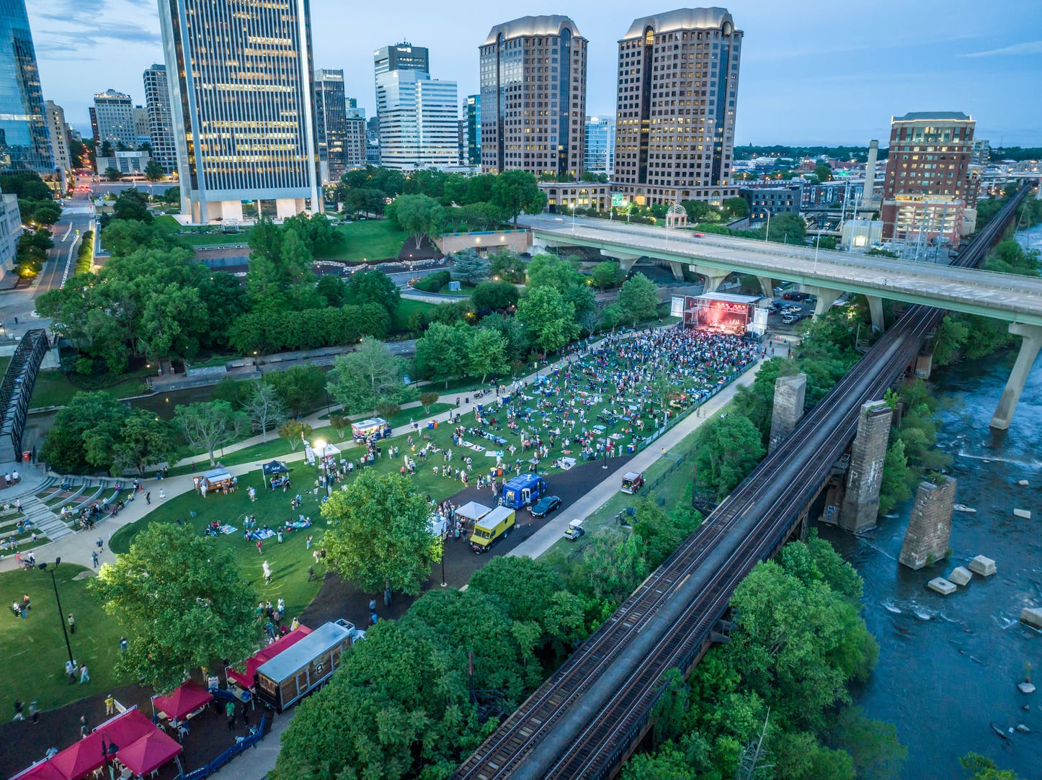

Venture Richmond
200 South Third Street
Richmond, VA 23219

2025 EVENT SUMMARY INFORMATION
YOUR EVENT MUST BE AT LEAST 90 DAYS FROM THE DAY YOU SUBMIT THE APPLICATION FOR PROCESSING. COMPLETION OF APPLICATION DOES NOT GUARANTEE APPROVAL.
DESCRIPTION
Name of Event _______________________________________________________________
Event(s) Date Requested _______________________________________________________________

Event Category ____Concert/Performance ____Dance _____Walk/Run/Athletic
____Festival/Celebration ____Exhibits . _____Special Attraction
____Other (please explain ______________________________________________)
Estimated Attendance _____________________________________

DATE/TIME
Event Start Time ___________________________ Event End Time ___________________________
Event Load In Date _____________ Event Load-in Start Time ______________
Will you need the next day to complete dismantling your event? ____Yes (additional fees will be applied) _____No
2025 APPLICANT CONTACT INFORMATION - Please Print
Primary Event Producer Contact
- Name ______________________________________________________________________________________
- Mobile/Cell Number __________________________________________________________________________
- Email Address ___________________________________________________________________________
- Mailing Address ____________________________________________ City/State/Zip______________________
- Have you been convicted of a crime? ___Yes ____No
- If yes, please explain ______________________________________________________________________________
Secondary Event Producer Contact (Required)
- Name ____________________________________________________________________________________
- Mobile/Cell Number ________________________________________________________________________
- Email Address ___________________________________________________________________________
- Mailing Address ____________________________________________ City/State/Zip___________________________
- Have you been convicted of a crime? ___Yes ____No
- If yes, please explain __________________________________________________________________________
Name of organization(s) sponsoring this event (required)_____________________________________________
Name of Executive Director/President/ CEO (required) _______________________________________________
Event Website (required)______________________________________________________________________

Please list any professional event organizer or event service provider hired by you that is authorized to work on your behalf to plan, produce and/or manage your event.
Name __________________________________________________________________________________________
Company’s Name _______________________________________________________________________
Company’s Website: _________________________________________________________
Address____________________________________________________ City/State/Zip _______________________
Telephone (Mobile) ___________________________________ Office/Work __________________________

DESCRIPTION OF EVENT – Please Print
Provide a narrative and details of your event.

RELATED EVENT ACTIVITIES
ALCOHOL
___ Yes ___No Does your event involve the use of alcoholic beverages?
If yes, please check all that apply.
___Sell Alcohol (VA Alcoholic Beverage Control and City of Richmond Alcoholic Beverage Control Licenses are required)
___Give Alcohol Away (VA Alcoholic Beverage Control and City of Richmond Alcoholic Beverage Control Licenses are required)
Venture Richmond must have copies of both licenses prior to your event. (Requirement)

FOOD VENDORS
____Yes ____No Does your event include food vendors?
ALL food vendors must have a current City of Richmond business license and current certificate of insurance specifically for this event. Venture Richmond must have copies on file prior to your event. This is a requirement.
Food vendors are required to pay a Meal Tax to the City of Richmond

MERCHANDISE VENDORS
____Yes ____No Does your event include merchandise vendors?
ALL merchandise vendors must have a current City of Richmond business license and current certificate of insurance specifically for this event. Venture Richmond must have copies of file prior to your event. This is a requirement.

TICKETED EVENT/ADMISSIONS
____Yes ____No Is this a ticketed event?
____Yes ____No Will tickets be sold in advance?
____Yes ____No Will tickets be sold at the gate/day of event?
The City of Richmond requires event producers to pay an Admissions Tax if you’re having a ticketed event or if you are charging patrons to attend your event.
AMPLIFIED SOUND
____Yes ____No Are there any musical entertainment related to your event?
If yes, name of performer/band and music type ____________________________________
_______________________________________________________________________________________________

___Yes ____No Will sound amplification be used?
If yes, name of professional sound company and including their complete address with city and state (required) _________________________________________________________________

___Yes ____No Will any Airborne Objects be used/distributed at your event?
If yes, please describe the type of items and reason for use __________________________
______________________________________________________________________________________________

2025 INSURANCE INFORMATION
Name of Insurance Agency/Carrier __________________________________________________________________
Address __________________________________________________________
City/State/Zip___________________________________________________
Insurance Agent Name ______________________________________ Email Address_________________________
Telephone: Day_________________________________ Cell ________________________________

TERMINATION
Venture Richmond may terminate this agreement immediately upon serving written notice to the Sponsor/ Organization if there is default by the Sponsor/Organization under any provision of the agreement, and the Sponsor/ Organization shall have failed to completely resolve the default within five days after being given notice by Venture Richmond. If notice is served less than six days prior to the event, the Agreement will terminate prior to the rental period, unless the default is completely resolved prior to the rental period. The sponsor/organization agrees to indemnify, save and hold harmless the city of Richmond, Venture Richmond, including their employees, agents and volunteers, from and against any and all costs, losses, diminutions in value, damages, liabilities, or expenses, without duplication, including, without limitation, reasonable attorneys’ fees and all amounts paid for investigation, defense or settlement of any of the foregoing to the extent such costs, losses, diminutions in value, damages, liabilities or expenses are arising out of or resulting from Sponsor/Organization’s actions or the event put on by the Sponsor/Organization. The sponsor/organization agrees to indemnify, save and hold harmless the city of Richmond, Venture Richmond, including their employees, agents and volunteers, from and against any and all costs, losses, diminutions in value, damages, liabilities, or expenses, without duplication, including, without limitation, reasonable attorneys’ fees and all amounts paid for investigation, defense or settlement of any of the foregoing to the extent such costs, losses, diminutions in value, damages, liabilities or expenses are arising out of or resulting from Sponsor/Organization’s actions or the event put on by the Sponsor/Organization. All revisions, changes, additions to any terms of this agreement must be in writing and approved in writing and dated by all parties. The signature below indicates that the sponsor/organization has reviewed and agrees to the conditions and restrictions in this agreement. I/We certify that all information given is correct and I hereby grant permission to Venture Richmond to conduct a criminal background check. Venture Richmond reserves the right to cancel any event if application information is found to be false.
Two SIGNATURES are REQUIRED

Primary Event Contact Signature ____________________________________________________________________
Date______________________________________________________________
Primary Contact Date of Birth ______________________________________ (MM/DD/YYYY)
Social Security # _________________________________________________

Secondary Event Contact Signature _________________________________________________________________
Date ________________________________________________________________
Secondary Contact Dater of Birth _____________________________________ (MM/DD/YYYY)
Social Security# ___________________________________________________

APPLICATION FEE (REQUIRED)
This application must be accompanied by a $200 application fee. Make checks payable to Venture Richmond. Applications will not be considered if 1) incomplete and/or 2) application fee is not included. Mail to:
Venture Richmond
c/o Brown’s Island Rentals
200 South Third Street
Richmond, VA 23219
www.venturerichmond.com

Completion of this application does not guarantee approval.
Your application will be reviewed for a final decision. Please allow 10 business days for a review. All applicants will receive an email with our final decision pending response from City of Richmond Finance and Tax Enforcement. See Required Next Steps below.

Until you have received an official approval email from Venture Richmond, do not post any type of marketing, publicity or social media advertisement for your pending event on Brown’s Island.

**REQUIRED NEXT STEP**
ALL EVENT PRODUCERS ARE REQUIRED BY THE CITY OF RICHMOND TO OBTAIN A CITY OF RICHMOND BUSINESS LICENSE. CONTACT THOMAS CUMMINGS WITH TAX ENFORCEMENT AFTER COMPLETING THIS APPLICATION. HIS EMAIL CONTACT INFO: thomas.cummings@rva.gov

BUSINESS LICENSE APPROVAL FROM THE CITY OF RICHMOND IS NOT AUTOMATIC APPROVAL FOR AN EVENT ON BROWN’S ISLAND/ RIVERFRONT PROPERTIES. VENTURE RICHMOND IS RESPONSIBLE FOR FINAL EVENT APPROVAL.

